
AKT1 (E49K)
Catalog Number: CR-M26137
Gene Symbol: AKT1; AKT; CWS6; PKB; PKB-ALPHA; PRKBA; RAC; RAC-ALPHA
Description: Anti-AKT1 (E49K) Mouse Monoclonal Antibody

Background: AKT1 is one of 3 closely related serine/threonine-protein kinases (AKT1, AKT2 andAKT3) called the AKT kinases, which
regulate many processes including metabolism, proliferation, cell survival, growth and
angiogenesis. Its function is mediated through serine and/or threonine phosphorylation of a
range of downstream substrates. There are
evidences that mutation or abnormal expression in AKT1 is associated with cancers.
Immunogen: A synthetic peptide from the internal region of AKT1 which includes the mutation of E49K, human origin.
Tested applications: ELISA, WB, IHC Recommended dilutions:
ELISA: 1:1000-1:5000
WB: 1:500-1:2000
IHC: 1:50-1:100
Concentration: 1 mg/ml
Host: Mouse
Clonality: Monoclonal
Purity: Purified from ascites
Format: Liquid Storage buffer:
Preservative: no
Constituents: PBS (without Mg2+ and Ca2+), pH 7.4, 150 mM NaCl, 50% glycerol
Species Reactivity: Recognizes E49K mutant, but not wild-type AKT1 of vertebrates.
Storage Conditions: Store at -20°C. Avoid freeze / thaw cycles.

Western blot:
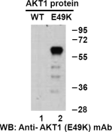
Western blot analysis of recombinant AKT1 (E49K) and wildtype proteins. Purified
His-tagged AKT1 (E49K) protein (lane 2) and corresponding wild type protein (lane 1) were blotted with anti-AKT1 (E49K) monoclonal
antibody (Cat. #26137).

For research use only. Not for diagnostic or therapeutic applications.
科博瑞（武汉）生物科技有限公司
TEL：027-87615885 15972062685
- mail：3636901710@qq.com
Web:www.coburybio.com

Immunofluorescence:
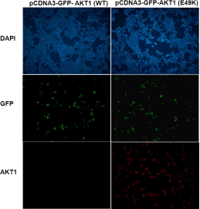
Immunofluorescence of cells expressing AKT1 proteins with anti-AKT1 (E49K) antibody.
HEK293T cells were transfected with
pCDNA3-GFP-AKT1 (WT) plasmid (left column) or pCDNA3-GFP-AKT1 (E49K) plasmid (right
column), then fixed and stained with anti-AKT1 (E49K) monoclonal antibody (Cat. #26137).

